Concept Generation and Selection Report
Group 12: Tri-Generation
Maggie Alvarado
Natalie Levings
Bruno Vieira

Concept Generation and Selection

From the problem statement and design requirements, the group has come up with the following concepts.

I. Alternative Fuels Concepts and Selection

Alternative Fuels under Consideration
The engine powering the Tri-generation system is to be converted to run on some alternative fuel. The advantages of using one of the previously mentioned alternative fuels are many. All of the options have a higher octane rating than gasoline. The engine life should be increased with the conversion for a number of reasons, regardless of which fuel is chosen. Lubricating oil life is extended considerably because these fuels do not contaminate and dilute the crankcase oil. Due to the absence of any lead content, the lead effects on the plugs are completely eliminated and plug life is significantly extended. Perhaps the most important factor is that gaseous fuels enter the engine in the form of a gas whereas gasoline enters in the form of spray or mist. This spray slowly washes away the lubricating oil from the piston ring area thereby increasing the rate of depreciation of the engine. Overall, the maintenance costs are reduced and engine life is increased with gaseous fuels. In addition, gaseous fuels burn much cleaner than gasoline, adding to the flexibility of the design. The fuels being considered are hydrogen, natural gas, and propane.

Hydrogen is the first fuel to be considered for use. Hydrogen has an octane rating of 130 because it can be compressed more than gasoline and 100% octane before the fuel automatically ignites in the engine. This is significantly higher than the 92 octane rating of premium gasoline.

Compressed Natural Gas (CNG) is the second fuel to be considered. CNG also has an octane rating of about 130. Converting the engine to use CNG can be easily done using parts from conversion kits available for purchase.

Propane is the third fuel to be considered. Propane has an octane rating of about 104. Like CNG, converting the engine to use propane needs a conversion kit.

Since each fuel calls for the need of conversion kit, the conversion kits need to be explored and the appropriate one selected. Hydrogen conversion kits are generally more expensive, already adding to the higher cost of the fuel. The kits for CNG and propane both generally work the same way. First, regulators lower the pressure gradually, with the first reduction being the largest one. This first part of the process would be bypassed, with the expansion of the gases to be used to cool a second environment. Once expanded, with its pressure lowered, the fuel would then be introduced into the converter. While some kits are designed for dedicated alternative fuel usage, some offer the option of keeping the capability of running on gasoline. These kits might use, or modify the carburetor, making the conversion a one-time process. In addition, options are available to install systems that allow the engine to run on gasoline, making it a Bi-fuel system. The kits that allow the dual-fuel capability of the engine leave the carburetor alone and monitor the fuel/air mixtures on its own injecting the optimal fuel mixture through its own process into the engine. These kits are slightly cheaper and more efficient due to the fact that they use the engine’s existing component to inject the fuel, basically duplicating the exact process the engine was designed to do, the dual-fuel system would significantly add to the versatility of the tri-generation system. In a situation where fuel might be scarce, the ability of using two different fuels could greatly expand its capabilities.

Alternative Fuel Selection
Looking at each fuel and the necessary conversion kits, the selection can finally be made. Many criteria are to be considered for selection. Cost, availability and ease of fitting with current system are the most important criteria. The need for the current fuel being able to integrated into the current system is met by all three of the alternative fuel sources under consideration. The second criterion is cost. The high costs outweigh the advantages when it comes to hydrogen. The conversion kits for both CNG and propane are relatively inexpensive with prices ranging between $150 and $300. The third criterion is availability. As for the decision between propane and CNG, due to the simple fact that propane is more readily available than compressed natural gas, would make it a more attractive option. Looking at all of the criteria, the alternative fuel to be selected is propane.

II. Water Management Solutions Selection

Conceptual Designs

The following conceptual designs were fabricated based on the need for a way to keep the water-heating unit from getting damaged due to the temperature reaching a maximum temperature of 95°C only 1 hour and 43 minutes into the process. The three concepts under consideration are adding an automatic bypass system with distiller addition, adding a water-heating unit bypass with distiller addition and increasing the water reservoir size.

The first concept being considered is an automatic bypass system with an addition of a distiller. This concept is based on a system that would control the heat into both the conduction circuit and the water-heating unit. The excess heat would then be used to generate steam that would be used in a distiller. The modification to the current system is shown below in Figure 1. This concept would help solve two current problems of excess heat to the absorption refrigeration and the water-heating unit. The added distiller would use the excess heat from the exhaust to generate steam.
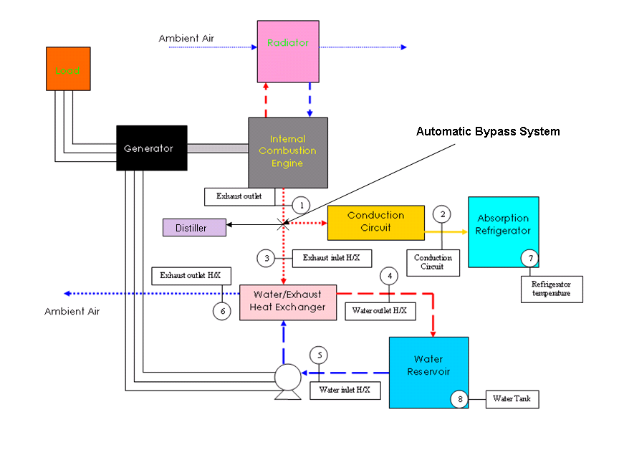
Figure 1:Modification to System with addition of
Automatic Bypass System

The second concept being considered is one with a water-heating unit bypass and an addition of a distiller. This system involves controlling the heat input into the water-heating unit. The modification to the current system is depicted in Figure 2. The figure depicts the placement of the bypass before the heat from the exhaust reaches the heat exchanger. The heat from the exhaust would go to a distiller and the water-heating unit. The heat to the water-heating unit would also be controlled manually by a valve so water is heated only when need by the user. This design would prevent overheating of the water-heating unit since the water-heating unit would only be used when needed. All of the waste heat then would be redirected to run a distiller that would provide freshwater.

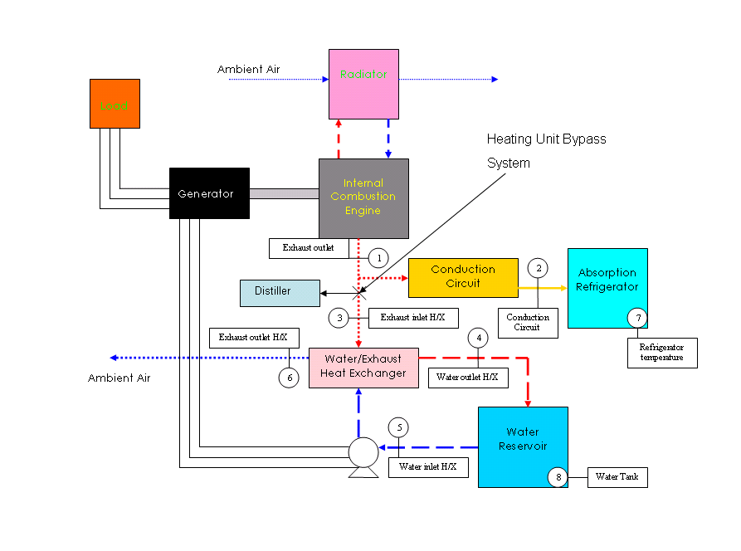
Figure 2: Modification to System with Heating Unit
Bypass System and Distiller

The third concept under consideration involves increasing the size of the water reservoir. The modification to the system is shown in Figure 3 below. By increasing the size of the water reservoir, more heat from the exhaust can be absorbed and overheating would no longer be a problem. Increasing the water tank size though may make the whole unit cumbersome to transport but it would be the most cost effective option.

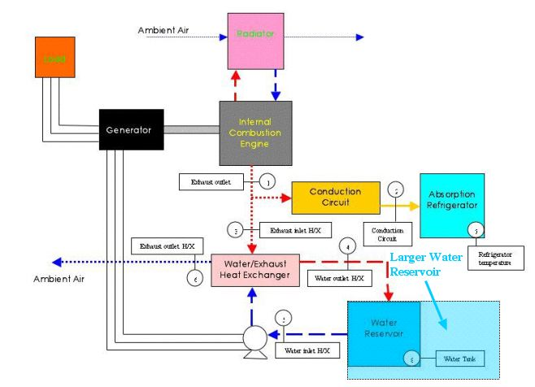
Figure 3: Modification to System by increasing
Water Reservoir size.

Conceptual Design Selection

After considering all of the conceptual designs in controlling the heat to the absorption refrigerator the selection can be made. Based on the problem presented either design should be equally effective which makes the governing criteria cost and physical constraints. Meaning, a conceptual design may be more affordable in theory but may be impractical with the given space constraints. Fabrication may be required to make a design more cost effective.

Decision Matrix
 | Cost | Meets Temperature Specifications | Ease in adding to current system | Total
Automatic Bypass System | 1 | 3 | 3 | 7
Water Heating Unit Bypass | 1 | 3 | 2 | 6
Increasing Water Reservoir Size | 3 | 1 | 1 | 4

III. Conduction Circuit Solutions Selection

Conduction Circuit Conceptual Designs

The prototype will have a heat bypass design to regulate the temperature in the cold space. Currently the prototype supplies a constant supply of heat to the absorption refrigerator. The heat bypass will interrupt the heat flow and allow for temperature regulation in the cold space. An absorption type system does not use a compressor but instead uses a generator.

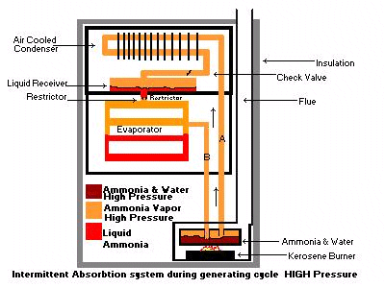

The intermittent absorption system uses a generator charged with water and ammonia. A heat source heats this solution in the generator. The ammonia is vaporized and driven off. A condenser, at the top of the system, condenses the ammonia vapor into a liquid. The liquid flows by gravity into the liquid receiver shown above and then into the evaporator. During the generating cycle, little or no refrigerating effect is taking place. As the system cools, the pressure drops, causing the liquid ammonia in the evaporator to boil (flash off) and absorb heat.

The heat source to the refrigerator is a piece of copper pipe that acts as a conduction circuit. The first design option for the heat bypass modification will consist of a valve and pipe bypass. The high temperature valve will reroute the exhaust gas before it reaches the conduction circuit. The bypass pipe will route the exhaust gas directly into the heat exchanger. The valve will be controlled by a pneumatic or electronic actuator. An actuator is a piece of equipment that produces movement when given a signal. Actuators are used in the computer control of an environment. The actuator will be signaled by the desired temperature in the refrigerator.

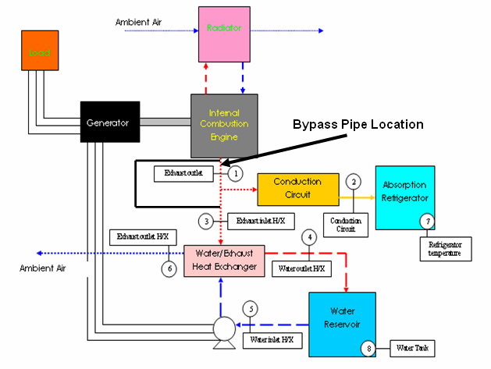

The second design will allow for a physical separation in the conduction circuit. No heat will be conducted from the exhaust gas to the refrigerator. The movement that breaks the conduction circuit will be regulated by an actuator. The actuator will receive a signal based on the temperature in the refrigerator.

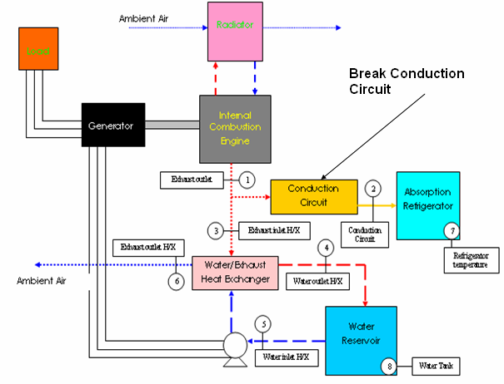

Conduction Circuit Conceptual Design Selection

After exploring all of the conceptual designs in controlling the temperature of the water-water heating unit, the selection can be made. Certain criteria must be looked at and how each concept applies it must be taken into consideration. From the problem statement and budget constraints cost, ease into fitting into current system and being able to reduce the temperature to 46°C to 95°C are the most important criteria involved.

 | Cost | Meets Requirements | Ease in adding to current system | Total
Valve and Pipe Bypass System | 1 | 3 | 2 | 7
Break Conduction Circuit | 2 | 3 | 1 | 6

